Practical Gaming 2026

Harvey Smith

T00264389

Name of Project

Gameplay
In this game, the overall goal is to reach the end of them temple, return to Avold (The human NPC) and get an ending depending on your actions throughout the game. The player will be faced with a few puzzles, enemies and a boss fight (depending on the ending) throughout the game. This will involve a degree of platforming, problem solving and combat to win.

The Bad Ending
To achieve this, play the game as normal by solving the puzzles and surviving to the end of the temple. There you will meet the cat who you may have seen or talked to earlier. He will notify you to go back to the beginning of the temple. When returning, and jumping down the hole, you will find Avold ready to escort you to safety. But once you turn around and walk away from him, he will stab you in the back, killing you. This achieves the bad ending. The only way to achieve the good ending, is to have been warned of his betrayal.

The Good Ending
To achieve this, you must have paid more attention to your surroundings and talked to the cat at the entrance to the temple. There is a low chance when talking to him, that instead of a meow, he will reveal he can speak and warn you about Avold. Continue the game as normal, with new alternate dialogue, and this time when Avold tries to betray you, you are ready. This will begin a boss fight against Avold that takes four hits to win. After winning and talking to Avold, the player will kill him, and reach the good end screen

Controls
Movement: WASD
Jump: SPACE
Dash: SHIFT
Look Around: MOUSE
Attack: LEFT-MOUSE/LEFT-CLICK

Coding
Under each of the following headings, please describe the concept, why is it or isn’t it useful/needed, where do you implement in your project, you may provide screenshots or cut and past code segments etc..

- Frame Rate Independence
Here I use frame rate independence to give a nice fluid animation as a sword moves into frame from off screen into frame. Using “moveSpeed * Time.deltaTime” I convert moveSpeed from per second to per frame, which means the movement will be clean no matter what hardware you are using 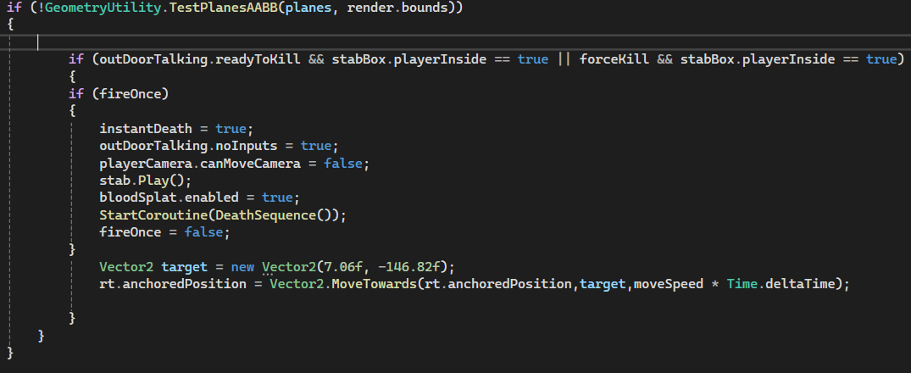

- Interfaces
In my project, I decided to use a very important interface that provides a method that returns whether the button has been activated or not.
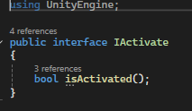
I used this as I had different objects that would trigger being activated in different ways. This interface allowed a consistent way for my door script to loop through each button and find whether it had been activated, not needing to know how the button itself was activated. The interface also makes my code easier to understand through reading the door script alone.

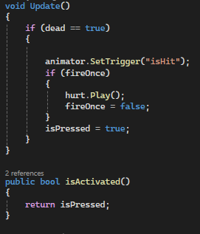
- Inheritance
I used inheritance inside my death screen script. Here, as this script works as a fade, I inherited my fade class to use its startFadeTransition() method.
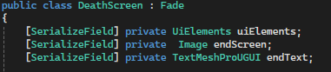
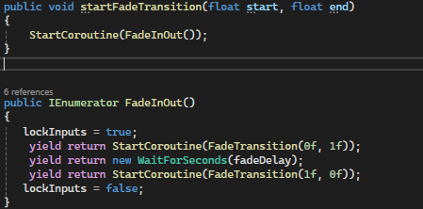
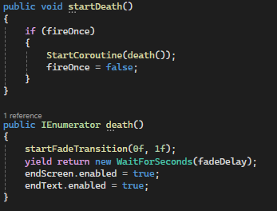

- Case pattern
I use a case pattern in my boss control script to control what state my boss currently is in, and what happens when the boss is in that state, and how it moves between those states
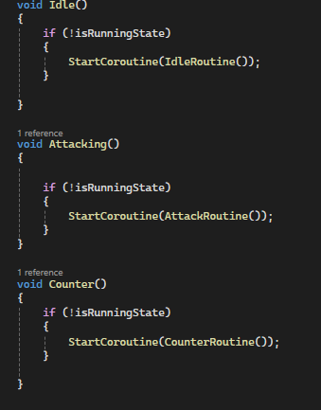
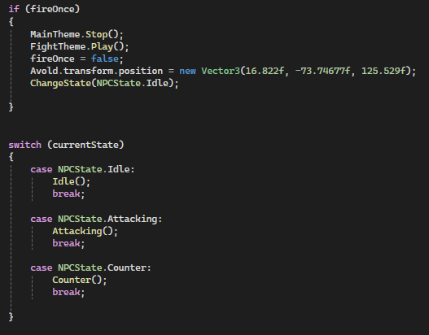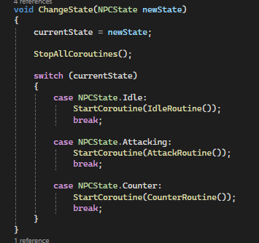
- Observer Pattern
I created an observer pattern where my death screen class was observing my uiElements class. I did this to observe the players health, so when it hits zero, the uiElements class will notify the observer class and run what should happen when the player dies
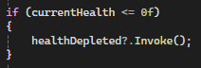
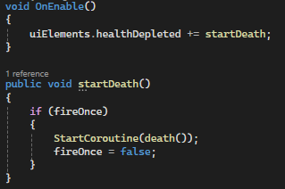
- Polymorphism
In my door script, to allow proper functionality, I used a method of polymorphism to allow the same function call to behave differently depending on the object its applied to. For example, I needed to do this as one set of my buttons are test dummies, which activate when hit, while the other set was enemies that activate when killed. The door script does not care about this, as I needed the door to only see IF it was activated, and thus polymorphism allows the door to treat the objects like they are the same and loop through them without issue.
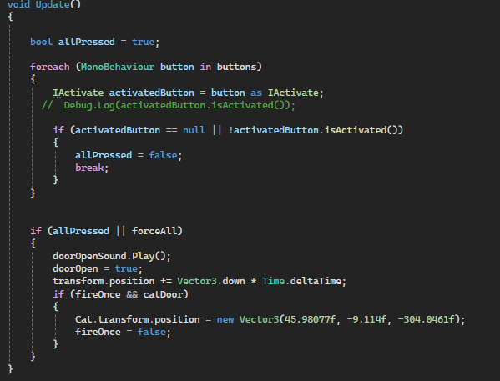
- Communication between scripts/game objects
There are many instances of my scripts communicating between each other in my project. Here is an example from my most prevalent script
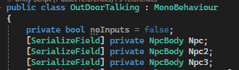
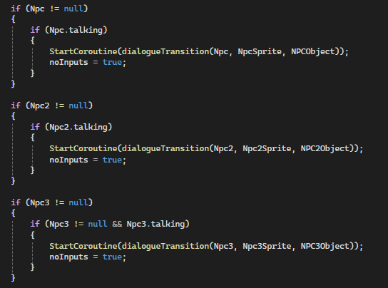
- Instantiation and Prefabs
I mainly used instantiation and prefabs in the use of my projectiles. Whenever my cannons/enemies are to shoot a projectile (or parryable projectile) one of my projectile prefabs are instantiated and use according to the script
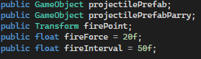
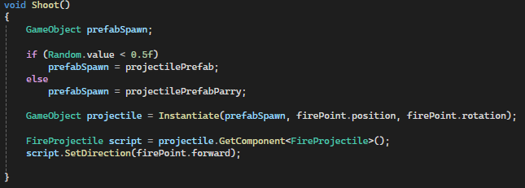

- Magic Numbers
The largest issue I had with my code overall, was my dialogue section. This included a huge number of magic numbers all throughout my code. I fixed this issue by instead using indexes from an array rather than directly using a magic number to call each desired line of dialogue. In other places in my project, I simply removed cases of magic numbers by creating a private value that I referenced rather than using magic numbers
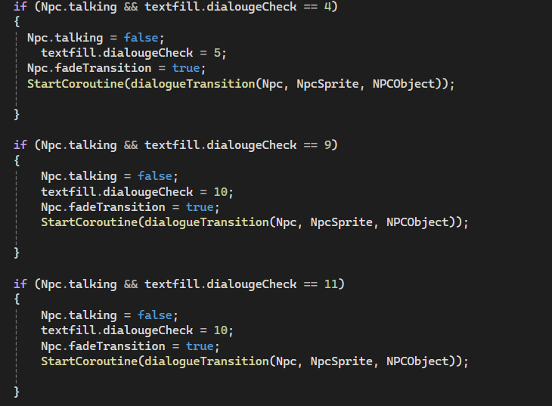
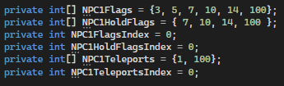

- Model Animation
Here are the animation models I used for my enemy movement, attacking etc. and the players sword swinging
Enemy Animator:
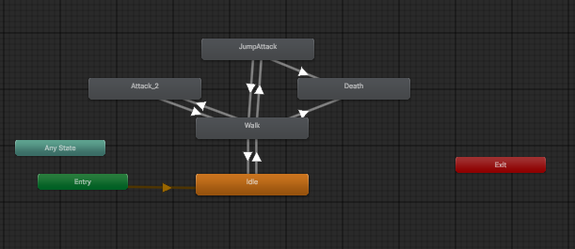
Sword Animator:
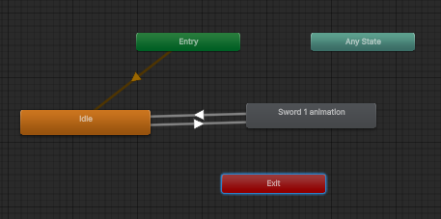

- Self made models and or animations
Here is the cannon I modelled myself in Maya and used in my project
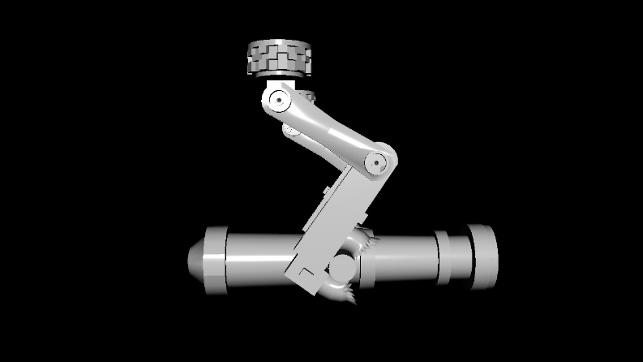
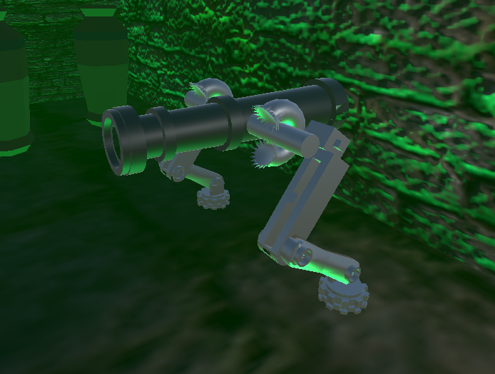

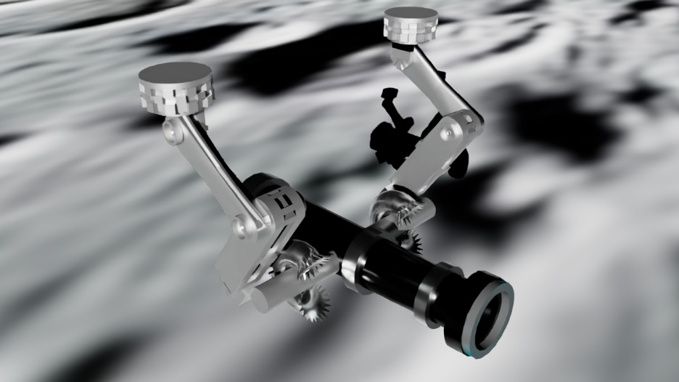

- Interactions between objects/scripts
Interaction between scripts and objects both occur here in my project
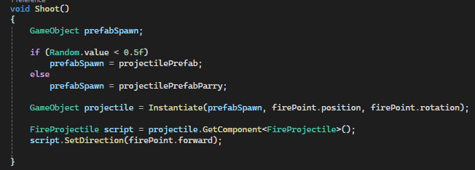

- Propper code placement
Here is proper code placement in my project
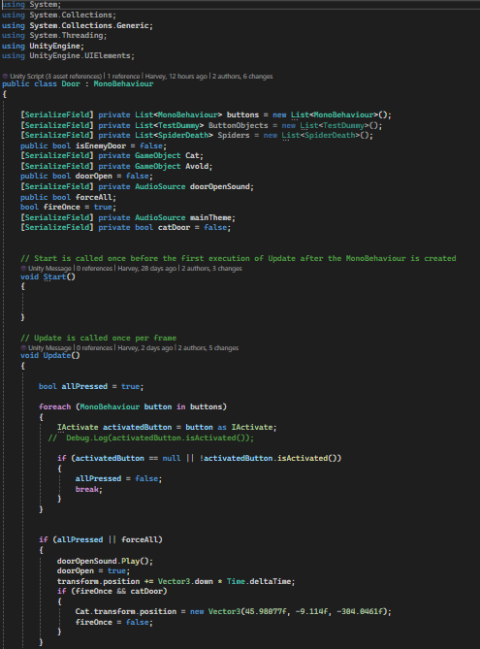
- Code repetition
Due to the way I coded my dialogue sequences, it contained a lot code repetition as shown here. As these are all the same, it makes sense to instead create a simpler way of controlling all this dialogue. To do this, I decided to use an array.
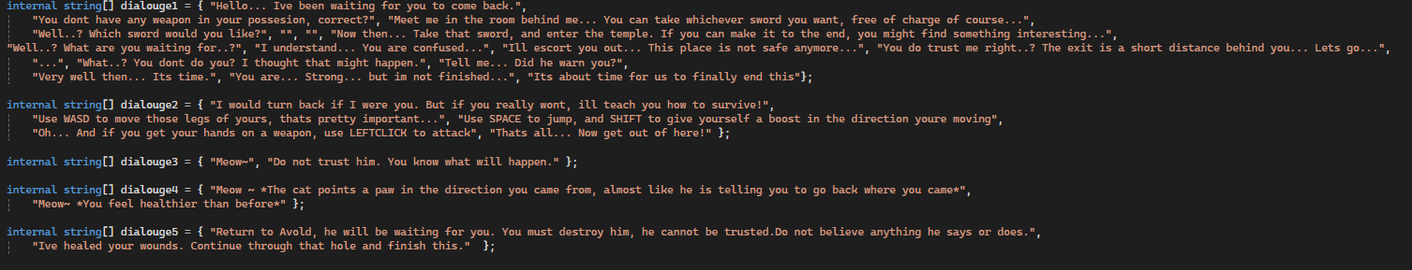


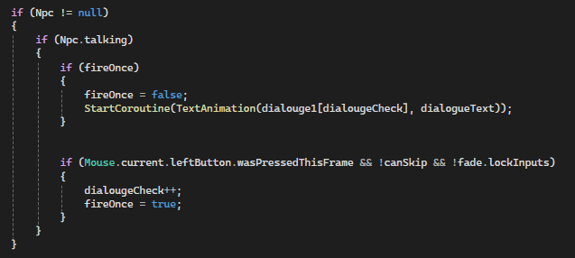

Here, I created an array that contained all the dialogue I used in the game, and instead of repeating the same piece of code over and over to set each line of dialogue individually, I now instead sequentially move through the array, and pick each piece of required dialogue, reducing my code repletion massively
- Feature 1
My code here includes a very nice visual feature for my dialogue sequences. By taking each vertice of the TextMeshPros mesh, and randomly moving it around in different directions, it creates this nice shaky text effect. This adds a lot more character and life into the text in my game as it conveys a scary/nervous feeling into the text, which fits the theme of my game well
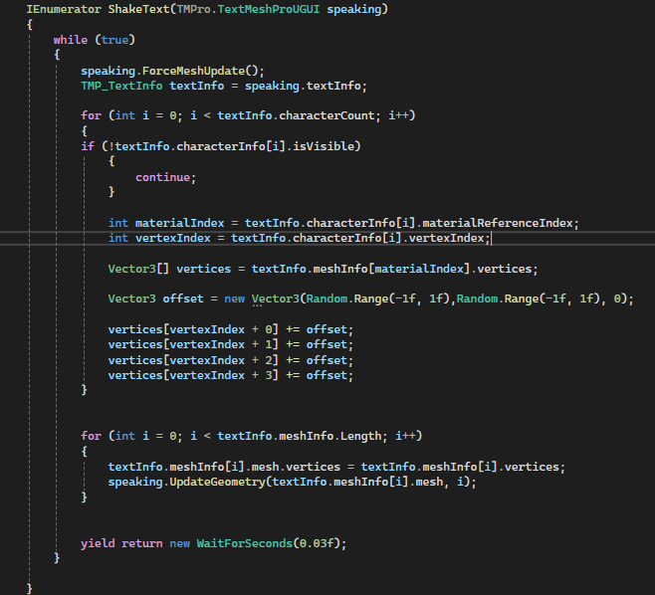

- Feature 2
Here in my boss fight, I created a tennis match like attack that the boss performs. The boss will fire a large projectile at the player, assuming the player does not miss and parries the attack, it will fly back towards the boss. In this section of the code, the state and direction of the attack is determined by checking the projectiles attack. If the projectile has the “ParryAttack” projectile, it will fly at the player. If it has the “CanHitBoss” tag, it has been parried and return to the boss. Then what happens is determined by my OnTriggerEnter().
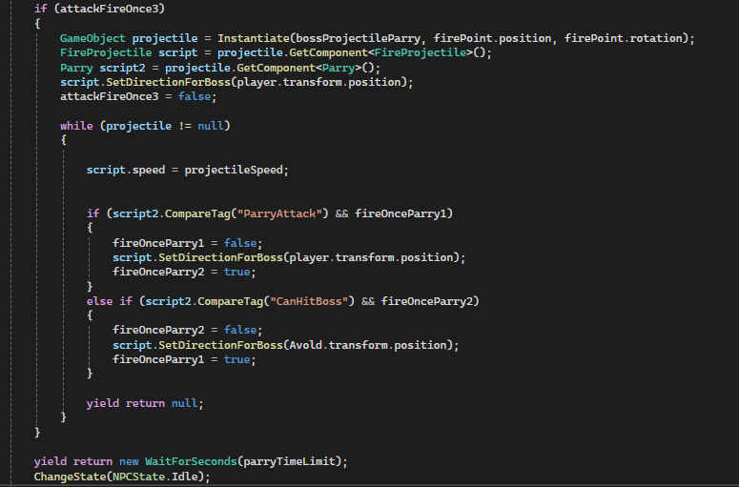
Here, when the boss is hit with the projectile, a random number is generated against a value. If this randomly generated number is less than the value, the tag will be changed to “ParryAttack”, and thus be sent back towards the player. I also increase the speed of the projectile and pitch of the music to match the intensity of the attack, as you play tennis with the boss. If the generated value is greater or equal to the value, it means the attack has successfully hit the boss. This will reset the projectile speed, reset the music pitch, destroy the projectile and increase the counter that determines how close the fight is to finishing
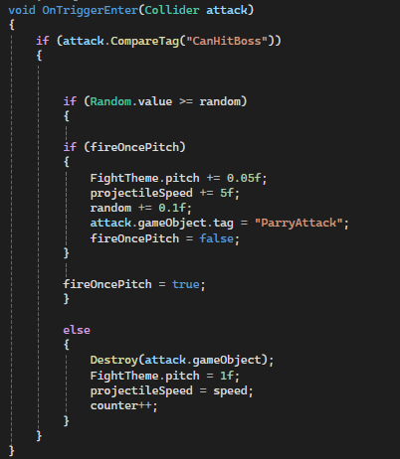
- Feature 3
For the bad ending of the game, I included a mechanic where when you look away from Avold, he stabs you in the back. When this happens, a number of effects occur and bring you to the end screen. This is done by checking if the desired object is currently off screen (out of view of camera). If yes, and the player is inside the kill box, the player is killed and the death sequence begins, giving the player the bad ending
